**npm install** is the command used to install any packages or node module using npm

im installing **lite server** it is a package used to show live changes from project into the web browser

**--save-dev** is used to save this info in package.json file

After that made some changes in package.json for ease changes were made in script in start and lite

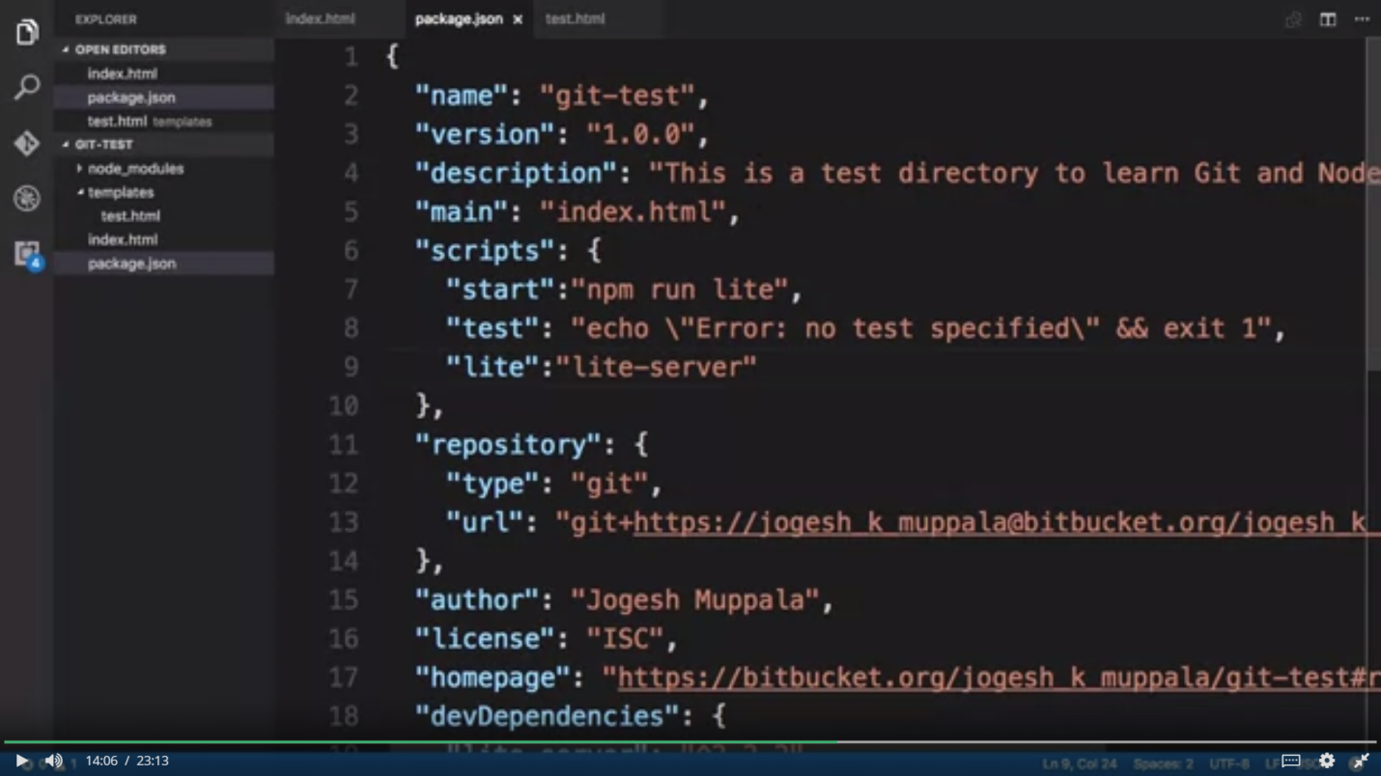

After that just use the comman **npm run lite**